Pickens Bass Fishing

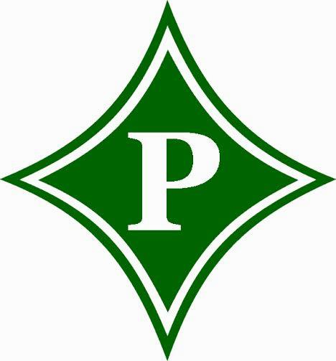

2020-2021
Sponsorship Information

Club Advisor: Coach Page• Email: bopage@pickenscountyschools.org
500 Dragon Drive Jasper, GA 30143 • Phone:(706) 253-1826 • Fax:(706) 253-1815
Website: http://pickensbass.weebly.com • Facebook: www.facebook.com/pickens.bassfishing
Follow us on Twitter @pickensbass

Sponsorship Levels
Title Sponsorship $500+
- Only FOUR Title Sponsorships Available
- Company Name will be the official sponsor of 1 of the 3 Pickens Bass Fishing Events or the Big Fish Award given at each event.
- Company Logo on Home Page of http://pickensbass.weebly.com
- Company Logo as Background Image on Facebook Page.
- Company Logo Placed on Front of Team Jersey
- Largest Company Logos on Team Banner Displayed at all Club Events
- Company Logo Displayed on sponsorship page of http://pickensbass.weebly.com
- Recognition on Facebook and Twitter Pages
- Recognition in the Newspaper article following the assigned event.
Platinum Level Sponsorship $300
- Company Logo Placed on Front of Team Jersey
- Large Company Logo on Team Banner Displayed at all Club Events
- Company Logo Displayed on http://pickensbass.weebly.com
- Recognition on Facebook and Twitter Pages
Gold Level Sponsorship $200
- Company Logo Placed on Sleeve of Team Jersey
- Large Company Logo on Team Banner Displayed at all Club Events
- Company Logo Displayed on http://pickensbass.weebly.com
- Recognition on Facebook and Twitter Pages
Silver Level Sponsorship $150
- Company Logo Placed on Back of Team Jersey
- Small Company Logo on Team Banner Displayed at all Club Events
- Company Logo Displayed on http://pickensbass.weebly.com
- Recognition on Facebook and Twitter Pages
Bronze Level Sponsorship $125
- Company Logo Displayed on http://pickensbass.weebly.com
- Recognition on Facebook and Twitter Pages
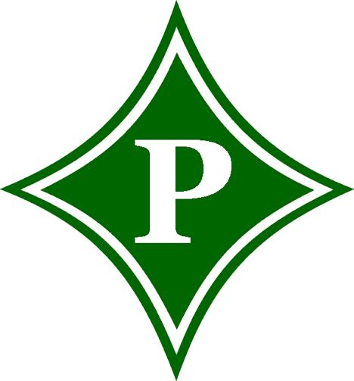
Pickens
Bass Fishing
Company Name | Contact Name
Company Address | Contact Phone
 | Contact Email
Please select the sponsor ship level that best fits your business.

______ Title Sponsorship ($500 minimum) -Only Four Available

______ Platinum Level Sponsorship ($300)

______ Gold Level Sponsorship ($200)

______ Silver Level Sponsorship ($150)

______ Bronze Level Sponsorship ($125)

Club member you would like to receive credit for your sponsorship:

Please make all checks payable to:
PHS Bass Club
Information and checks may be returned with club member or mailed to:
PHS Bass Club
Attn: Bo Page
500 Dragon Drive Jasper, GA 30143
Thank you again for your support! All proceeds from corporate sponsorships go to directly benefit Pickens High School Bass Fishing Club and its members.
A sponsorship at any level may be used to cover the club fees of a particular member.
Your sponsorship will provide that club member with the following:
A Team Jersey -Membership into The Bass Federation- A Team Hat
All other funds will be used for club wide expenses.

See Your Logo on Our Athletes!
